Spring Core and Maven

Creating and Configuring a Maven Project

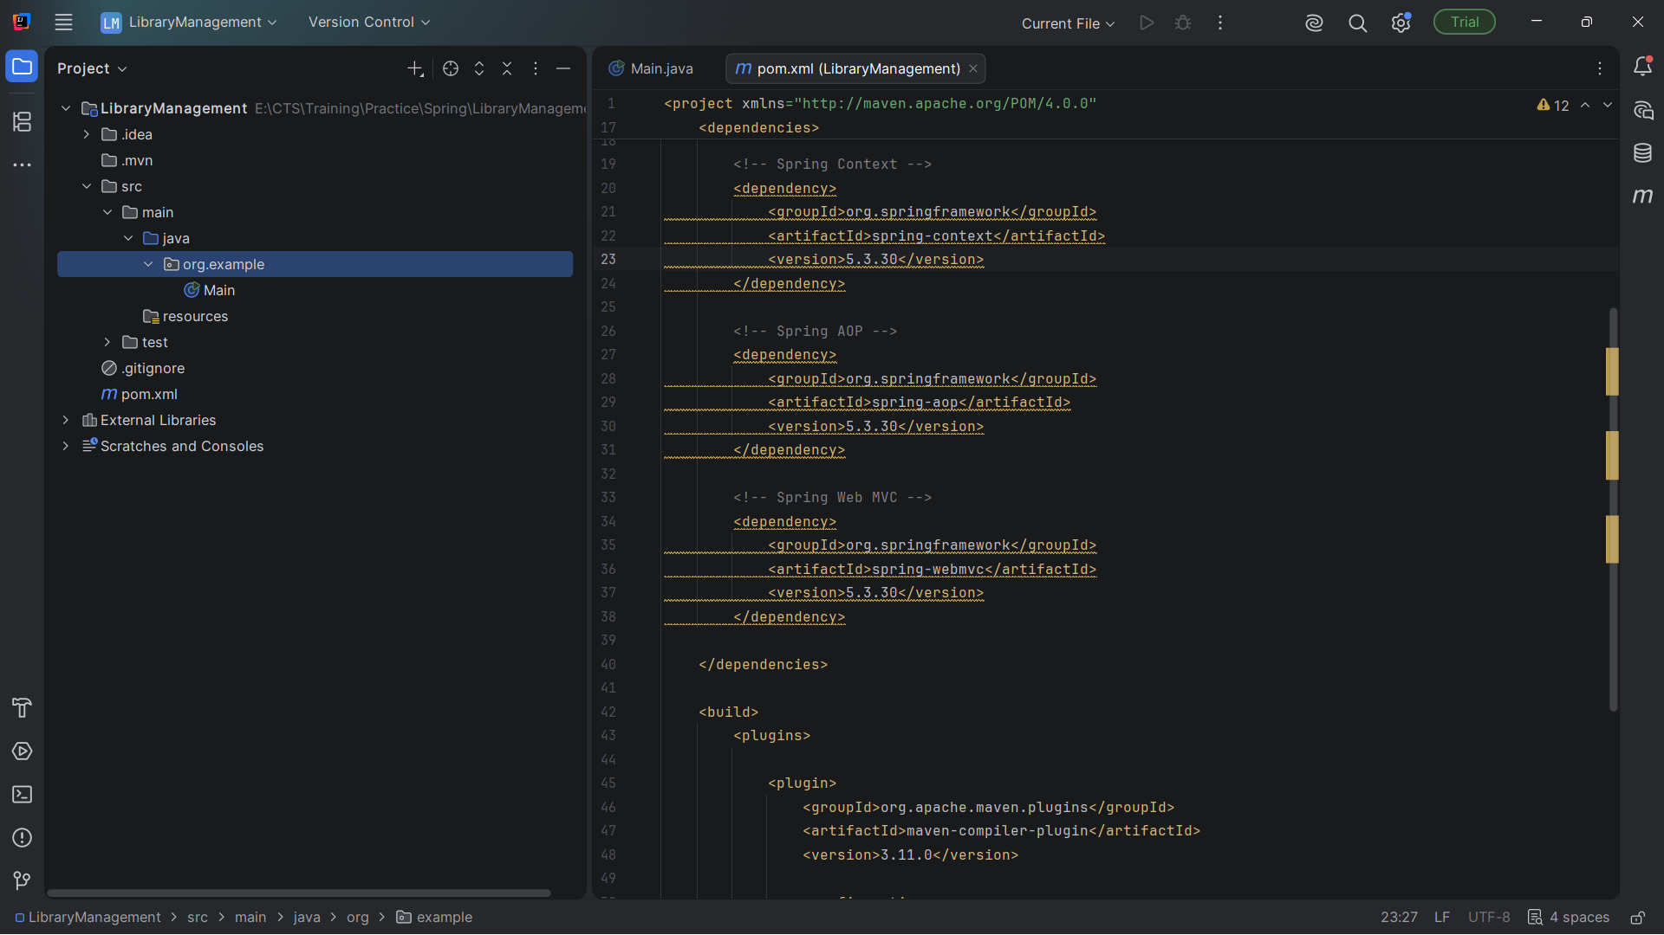
Creating and Configuring a Maven Project

Configuring a Basic Spring Application

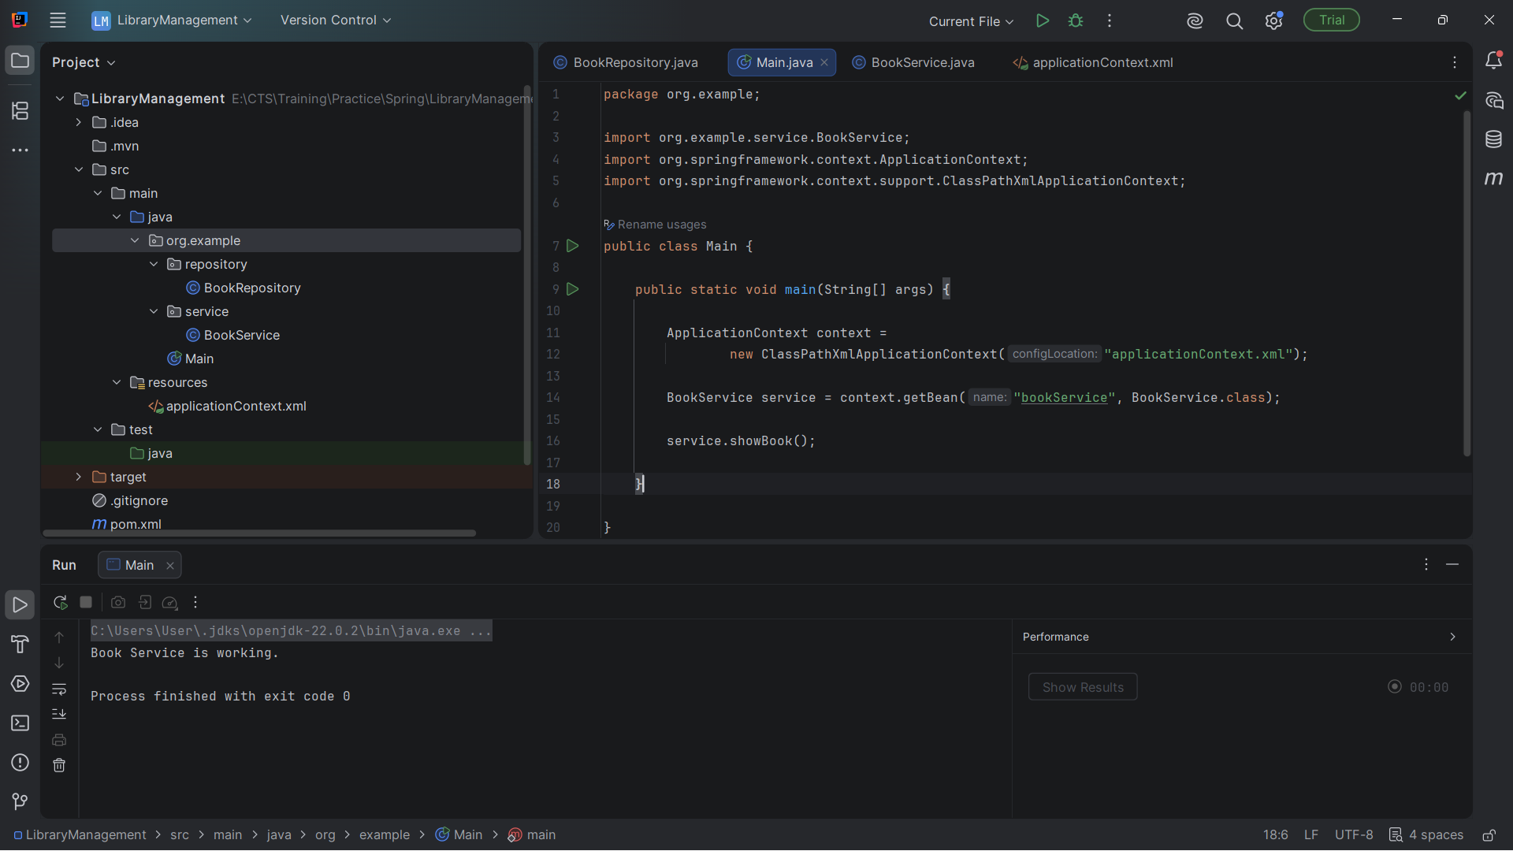
Fetching from service package

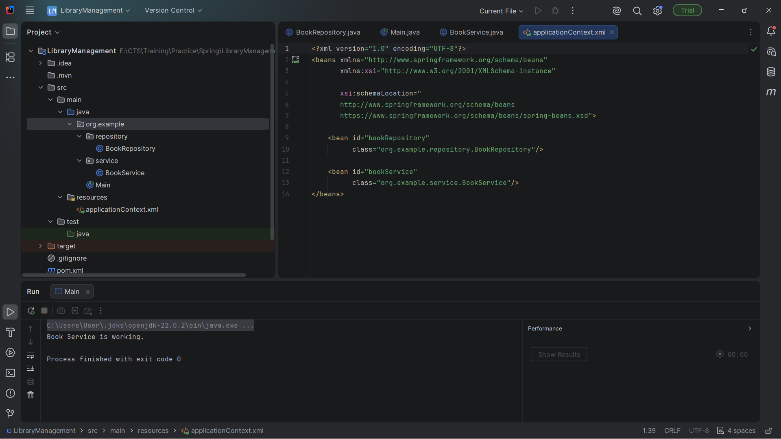
Configuring using ApplicationContext

Implementing Dependency Injection

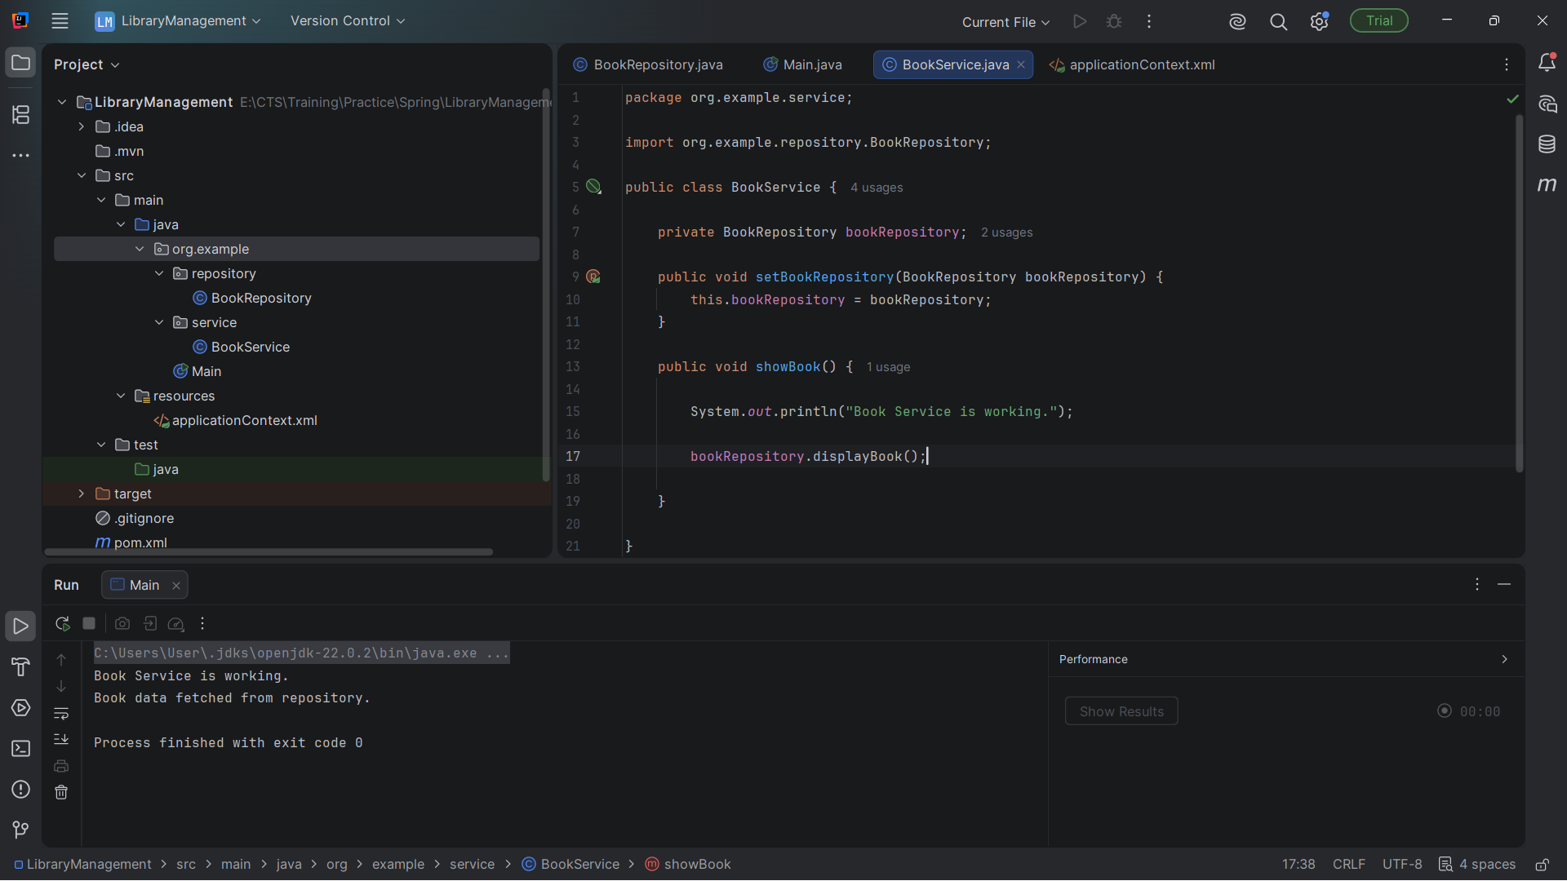
Injecting Dependency in service repository

